|  |  |  |
| --- | --- | --- |
| July 3rd 2025 | European Summer Program  **Physics II (part 2)**  **Intermediate exam** | First name : |
| 40min | Last name : |
| **Without formula sheet - Only one answer per question !** | | |

1. **Chapter 31 – EM oscillations and alternating current**
2. How is energy primarily stored in an RLC circuit during free oscillations?

|  |  |
| --- | --- |
| A – Energy is stored as a magnetic field in the capacitance and as an electric field in the inductance. | B – Energy is stored in the capacitor as electrical field energy and in the inductor as magnetic field energy. |
| C – Energy is stored solely as heat in the resistor, with none in the capacitor or inductor. | D – By a continuous supply of energy from an external AC source. |

1. The process of energy exchange in an LC circuit can be described as:

|  |  |
| --- | --- |
| A – Energy from the inductor discharges into the resistor, then back into the inductor | B – Energy from the capacitor discharges into the inductor, then back into the capacitor |
| C – Energy from the power source discharges into the inductor, then back into the power source | D – Energy from the power source discharges into the inductor, then back into the power source |

1. What happens to the current in the LC circuit when the energy is completely transferred from the capacitor to the inductor?

|  |  |
| --- | --- |
| A – The current is maximum | B – The current is zero |
| C – The current is equal to the voltage | D – The current remains constant |

1. At what natural frequency does a series RLC circuit oscillate during free oscillations?

|  |  |
| --- | --- |
| A – The frequency is | B - The frequency is |
| C – The frequency is | D - The frequency is |
| E – The frequency is | F - The frequency is |

1. In an ideal LC circuit without resistance, the total energy:

|  |  |
| --- | --- |
| A – Decreases exponentially with time | B - Increases linearly with time |
| C – Remains constant over time | D - Oscillates with increasing amplitude |

1. In an RLC circuit undergoing forced oscillations, what determines the frequency at which the circuit oscillates?

|  |  |
| --- | --- |
| A – The natural frequency of the RLC circuit, determined solely by the values of R, L, and C. | B- The frequency of the external driving force, independent of the natural frequency of the circuit. |
| C – The resistance of the circuit, which dictates the oscillation frequency. | D- The initial charge on the capacitor, which sets the oscillation frequency. |

1. Which of the following best describes resonance in a series RLC circuit?

|  |  |
| --- | --- |
| A – Resonance is when the resistance of the circuit matches the reactance of the capacitor. | B- Resonance is when the driving frequency matches the natural frequency, and the voltage across the resistor becomes zero. |
| C – Resonance is when the sum of inductive and capacitive reactance equals the total resistance, maximizing impedance. | D- Resonance is when the frequency of the external driving source matches the natural frequency of the circuit, causing the inductive and capacitive effects to cancel. |

1. In physics, in general, what does the concept of impedance represent in an oscillating system (mechanical, acoustical or electrical)?

|  |  |
| --- | --- |
| A – The resistance to motion caused only by energy dissipation mechanisms like friction or electrical resistance. | B- The difference between the inductive and capacitive complex reactances. |
| C – The opposition to motion or signal propagation, combining both energy loss and phase shift effects. | D- The instantaneous force required to maintain oscillations at a fixed amplitude. |

1. At resonance in an RLC series circuit, the impedance is:

|  |  |
| --- | --- |
| A – Minimum | B - Maximum |
| C – Zero | D - Infinite |

1. Which of the following best describes the principle by which a transformer transfers energy between coils?

|  |  |
| --- | --- |
| A – Current in the primary coil creates a steady magnetic field that induces current in the secondary | B - Electric charge physically moves from the primary to the secondary coil through the magnetic core. |
| C – A time-varying magnetic flux in the transformer core induces an electromotive force in the secondary coil. | D - The transformer relies on resonant electric field coupling between the coils to transfer energy at specific frequencies. |

1. In an ideal transformer, if the number of turns in the secondary coil is twice that of the primary, what happens to voltage and current in the secondary compared to the primary?

|  |  |
| --- | --- |
| A – Voltage doubles and current doubles. | B - Voltage doubles and current halves. |
| C – Voltage halves and current doubles. | D - Voltage halves and current halves. |

1. **Chapter 32 – Magnetism of matter**
2. What is the origin of the total magnetic moment of an atom?

|  |  |
| --- | --- |
| A – The algebraic sum of the spin magnetic moments of all electrons. | B - The vector sum of the spin and orbital magnetic moments of all electrons. |
| C – The total orbital motion of electrons around the nucleus. | D - The overall negative charge distribution in the electron cloud. |

1. Which of the following statements best captures the nature of “spin” in quantum mechanics?

|  |  |
| --- | --- |
| A – Spin is an intrinsic property of particles, introduced to account for specific experimental observations. | B - Spin is an elementary magnetic monopole. |
| C – Spin describes the precession of a particle’s trajectory in a magnetic field. | D - Spin is the result of a particle physically rotating around its axis, creating a magnetic field. |

1. Which of the following best describes a diamagnetic material?

|  |  |
| --- | --- |
| A – It develops a weak magnetization opposite to the applied magnetic | B - It becomes strongly magnetized in the direction of an external magnetic field |
| C – It has permanent magnetic dipoles aligned in opposite directions. | D - It retains magnetization after the external field is removed. |

1. Permanent magnetism is primarily due to:

|  |  |
| --- | --- |
| A – Orbital and spin alignment of electrons in atomic domains. | B - Free electrons moving in a current. |
| C – Alignment of nuclear spins. | D - Large numbers of conduction electrons. |

1. Which type of material can retain magnetization after the external magnetic field is removed?

|  |  |
| --- | --- |
| A – Diamagnetic | B - Paramagnetic |
| C – Ferromagnetic | D - Magnetic |

1. What do paramagnetic and ferromagnetic materials have in common?

|  |  |
| --- | --- |
| A – They have no net magnetic moment per atom. | B - Their magnetic susceptibility is negative |
| C – They both contain atoms with unpaired electrons | D - They both exhibit hysteresis loops. |

1. When a paramagnetic material is subjected to an external magnetic field, it:

|  |  |
| --- | --- |
| A – Expels the magnetic field completely | B - Shows no change in magnetization |
| C – Retains permanent magnetization even after the field is removed | D - Becomes magnetized in the direction of the field but loses magnetization when the field is removed |

1. These images show the magnetic moments of different material. Link each picture to the corresponding materials

|  |  |  |
| --- | --- | --- |
| ● | ● | ● |
| ●  Diamagnetic material | ●  Paramagnetic material | ●  Ferromagnetic material |

1. What happens to a ferromagnetic material when it is heated above its Curie temperature?

|  |  |
| --- | --- |
| A – It becomes superconducting. | B - It becomes diamagnetic. |
| C – It becomes paramagnetic. | D - It remains ferromagnetic with reduced strength. |

1. 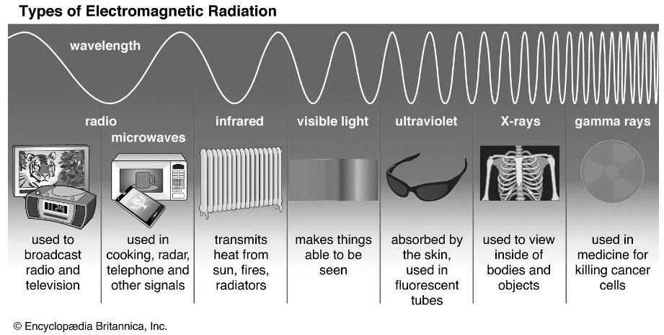 **Chapter 33 – Electromagnetics waves**
2. Which of the following EM wave has the minimum frequency?

|  |  |
| --- | --- |
| A – visible light | B - gamma rays |
| C – infrared | D - microwave |

1. Which component of an electromagnetic wave oscillates in the direction of wave propagation?

|  |  |
| --- | --- |
| A – Electric field. | B - Magnetic field |
| C –. Both | D - Neither |

1. The Poynting vector represents:

|  |  |
| --- | --- |
| A – The magnetic field strength of an electromagnetic wave | B - The direction and magnitude of electromagnetic energy flow per unit area per unit time |
| C – The polarization state of the wave | D - The electric potential of the wave |

1. Radiation pressure occurs because:

|  |  |
| --- | --- |
| A – EM waves carry mass that exerts force on surfaces | B - Photons carry momentum, which is transferred to surfaces when absorbed or reflected |
| C – The electric field oscillates rapidly causing pressure fluctuations | D- Magnetic fields push charged particles causing pressure |

1. How does the intensity of an electromagnetic wave vary with distance from a point source of power?

|  |  |
| --- | --- |
| A – Decreases linearly with distance | B - Decreases exponentially with distance |
| C – Remains constant regardless of distance | D - Decreases with the squared distance from  the source |

1. When light passes from air (n=1.0) to water (n=1.33), what happens to its speed and wavelength?

|  |  |
| --- | --- |
| A – Speed decreases | B - Speed increases |
| C – Speed remains the same, the speed of light | D - Speed depends of the incident angle according to Snell's second law |

1. Total internal reflection occurs when light travels:

|  |  |
| --- | --- |
| A – From a lower refractive index medium to a higher refractive index medium at any angle | B - From a higher refractive index medium to a lower refractive index medium at angles greater than the critical angle |
| C – At normal incidence on any surface | D - Only in optical fibers |

1. Which of the following best describes the polarization of an electromagnetic wave?

|  |  |
| --- | --- |
| A– The direction of the electric field vector oscillation in a plane perpendicular to the direction of wave propagation | B - The orientation of the magnetic field vector in the direction of propagation |
| C– The longitudinal orientation of the wavefront in dispersive media | D – The alignment of the wave’s velocity vector with the oscillation of the electric field |

1. A beam of “unpolarized” light is incident on a polarizing filter. Which statement is most accurate?

|  |  |
| --- | --- |
| A– The electric field of the transmitted light oscillates in one fixed direction | B – Some of the light is blocked because the filter reflects all magnetic field components |
| C– The light becomes circularly polarized after passing through the filter | D – The wavelength of the light is reduced due to absorption in the filter |